NAME: THARUN S

DEPT: CSE-1Y

COGNIZANCE TASK-8

**Question-1**

**Consider the vector [10, 11, 12, 13, 14], how to build a new vector with 5 consecutive zeros interleaved between each value?**

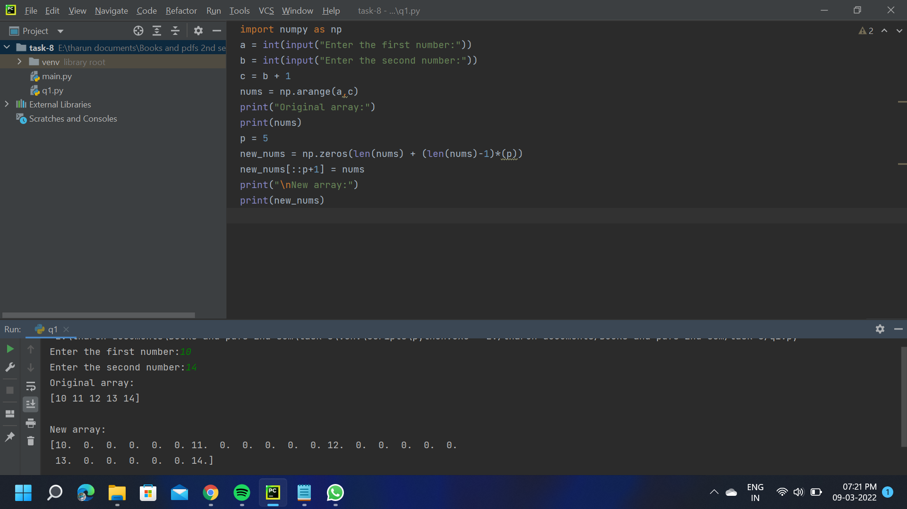

**Question-2**

#### Consider two random array A anb B, check if they are equal

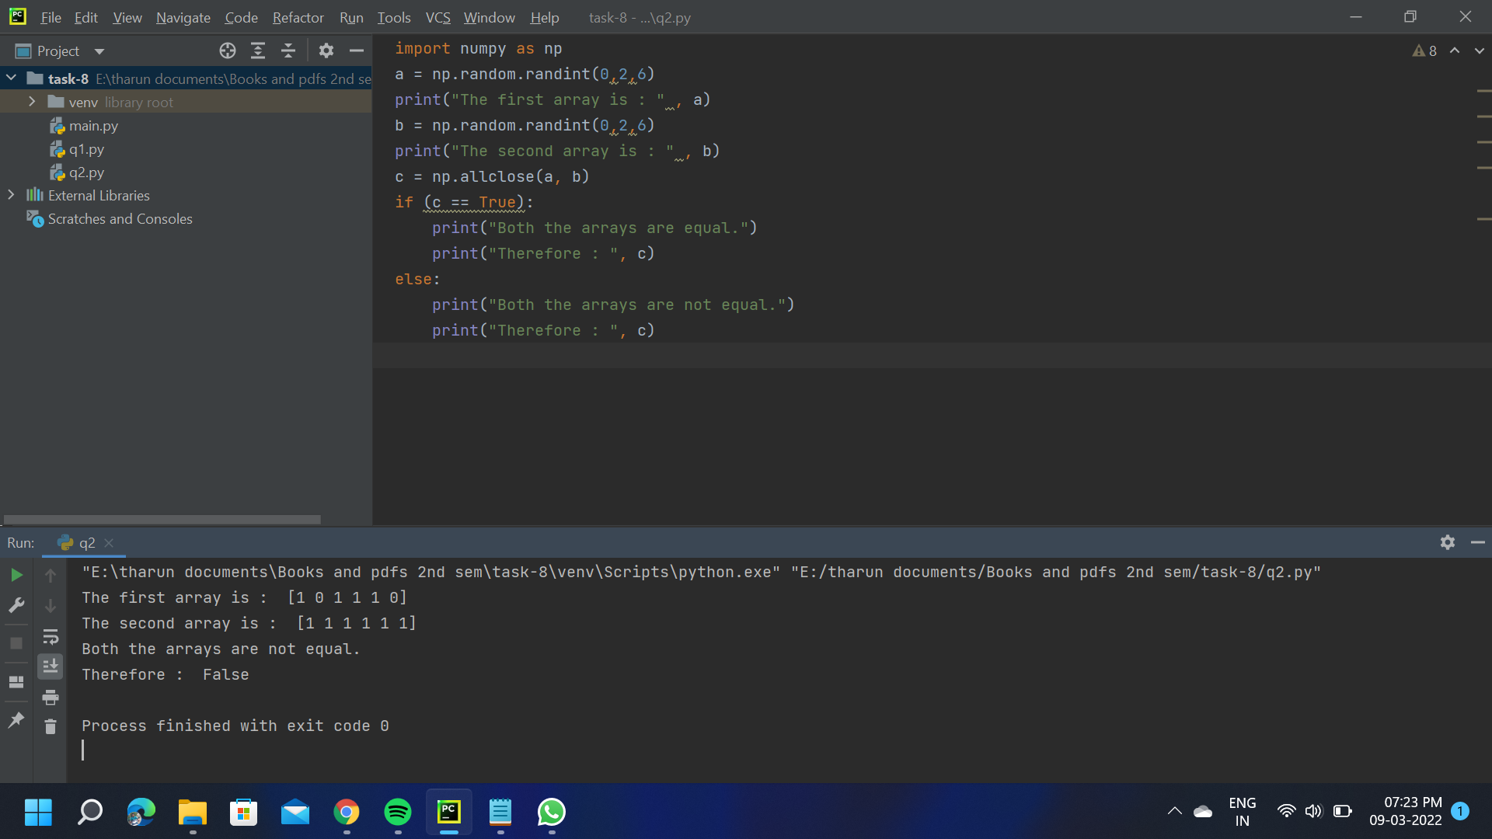

**Question-3**

#### What is the result of the following expression ?

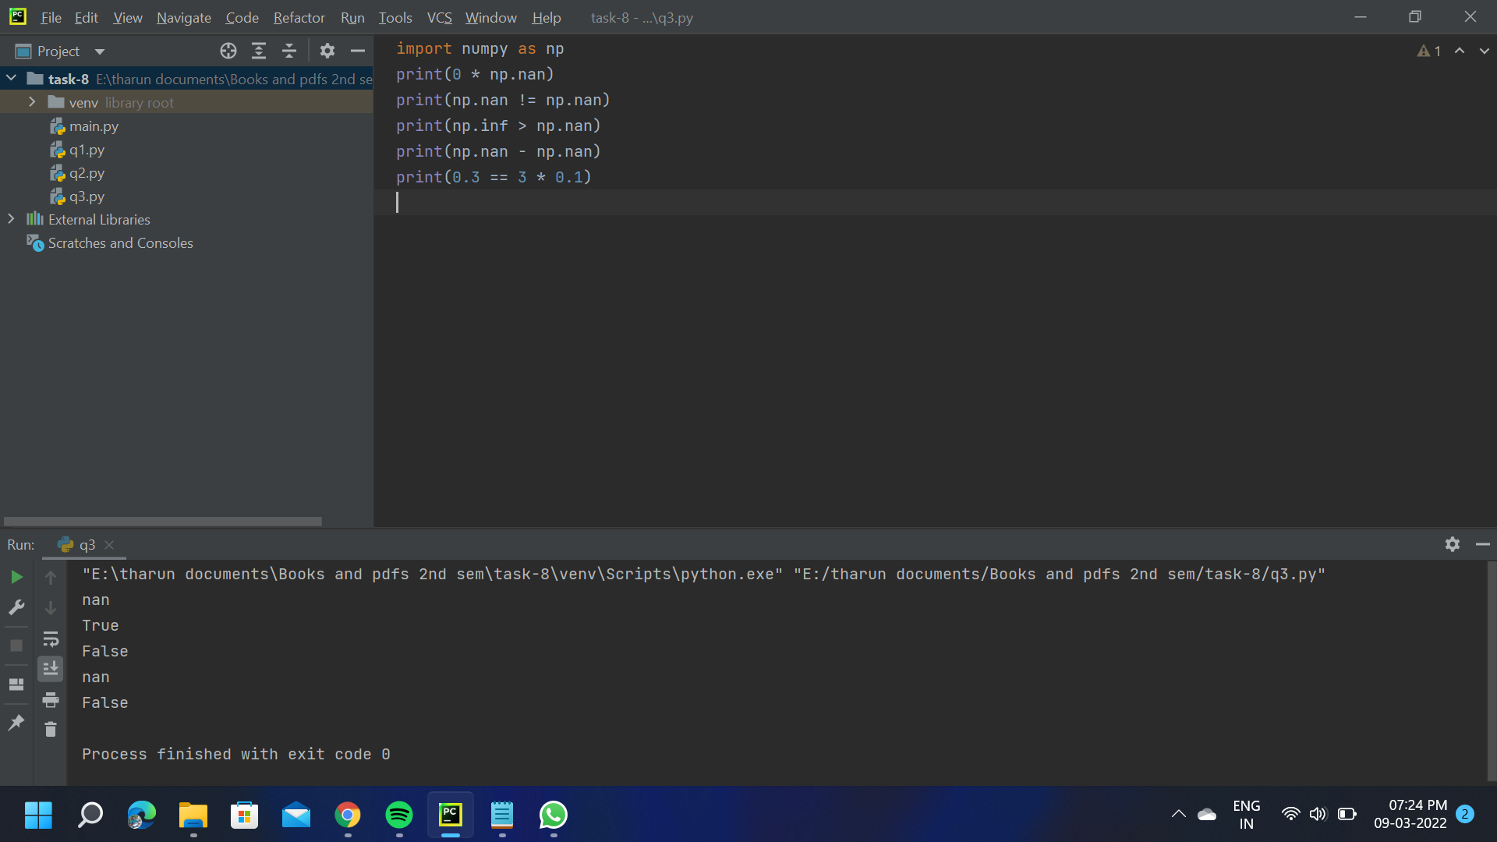

**Question-4**

#### Convert the first character of each element in a series to uppercase?

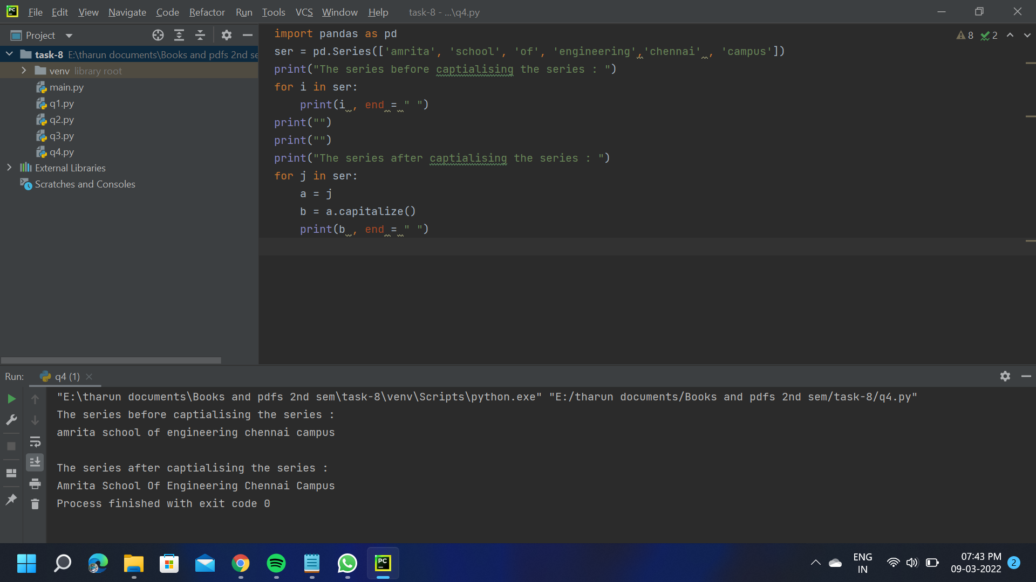

**Question-5**

**Do any two Exercises using Numpy**

|  |
| --- |
| 1.addition of 2 numpy arrays    2.Multiplying a matrix |

